

CY-4001
Digital Forensics

Project
MBR Integrity Verifier and Recovery Tool

Submitted by:
- Sarita Sangrez – 23I-2088
- Syeda Shanzay Shah – 23I-2016
- Fatima Naeem – 23I-2046
- Rumaisah Haroon – 23I-2106
Date: Wednesday, April 22, 2026

Table of Contents
1. Introduction to Tool and Forensic Domain 2
2. Legal & Ethical Considerations 2
3. System Requirements 2
4. Installation Steps 2
5. Step-by-step usage instructions 3
Member 1 - Disk & Image Handling Module 3
Member 2 – MBR & GPT Parsing 4
Member 3 – Integrity & Recovery 4
Member 4 – GUI & Integration 4
6. Example Cases with Screenshots 5
Case 1: USB Drive Forensic Image (clean_mbr.001 — .018) 5
Case 2: Two Separate VHDs created (mbr_test.vhd & gpt_test.vhd) 5
7. Interpretation of Results (Forensic Relevance) 8
8. Work Division 11
Member 1 — Disk & Image Handling Module 11
Member 2 — MBR & GPT Parsing Module 11
Member 3 — Integrity Verification & Recovery Module 12
Member 4 — GUI Interface & Reporting Module 12
9. References 13

Introduction to Tool and Forensic Domain
This project is a digital forensic tool designed to analyze and verify disk structures at a low level. Specifically, this module focuses on parsing and interpreting:
- Master Boot Record (MBR)
- GUID Partition Table (GPT)
In digital forensics, understanding partition structures is critical. The MBR or GPT contains information about how a disk is divided into partitions, which operating systems rely on to locate data. If these structures are modified, corrupted, or tampered with, it may indicate malware infection, anti-forensic activity, or system compromise.
This module extracts and parses raw disk data without modifying it, following forensic best practices. It reads sector-level binary data and converts it into human-readable structured information for investigation.

Legal & Ethical Considerations
Digital forensic analysis must follow strict legal and ethical principles:
- Evidence must never be modified during analysis.
- All operations must be performed in read-only mode.
- Original evidence must be preserved.
- Any modification must be done only on a working copy.
- Investigator must have proper authorization before accessing live disks.
This tool reads raw disk sectors but does not alter them. For recovery demonstrations, a duplicated test image is used instead of original evidence.
Unauthorized access to storage devices may violate privacy laws and cybersecurity regulations. Therefore, this tool must only be used in controlled academic or authorized forensic environments.

System Requirements
Operating System:
- Windows 10/11 (recommended)
- Linux/macOS (supported for image analysis)
Python Version:
- Python 3.10 or higher
Hardware:
- Minimum 4 GB RAM
- Sufficient disk space for VHD or forensic images
- Administrator/root privileges, required only for live physical disk access
Libraries Used:
- struct (for binary parsing)
- No external dependencies required

Installation Steps
Install Python
- Download Python 3.10+ from: https://www.python.org/downloads/
- Verify installation: python --version
Ensure project structure:
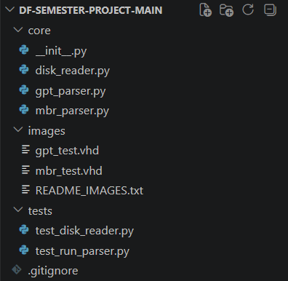
No pip installation required. This module only uses Python’s standard library.

Step-by-step usage instructions

Member 1 - Disk & Image Handling Module
- How other modules call Member 1's functions:
from core.disk_reader import (
read_mbr_from_image,
read_gpt_header_from_image,
read_backup_gpt_header,
read_mbr_from_live,
get_image_info,
)
- Reading the MBR from a forensic image:
mbr_bytes = read_mbr_from_image("images/clean_mbr.001")
Returns exactly 512 raw bytes — no processing applied
- Getting image metadata before processing:
info = get_image_info("images/clean_mbr.001")
print(info["total_size"]) # 41,587,310,592 bytes
print(info["total_sectors"]) # 81,225,216 sectors
print(info["is_split"]) # True
- Reading the Primary GPT Header (LBA 1):
gpt_bytes = read_gpt_header_from_image("images/clean_mbr.001")
- Reading the Backup GPT Header (last sector):
backup_bytes = read_backup_gpt_header("images/clean_mbr.001")
- Reading MBR from a live disk (Windows, run as Administrator):
mbr_bytes = read_mbr_from_live(drive_number=0)
# 0 = PhysicalDrive0, 1 = PhysicalDrive1, etc.
- Running the verification test:
python tests/test_disk_reader.py

Member 2 – MBR & GPT Parsing
- Importing the Parser Modules:
from core.mbr_parser import (
extract_boot_code,
extract_disk_signature,
validate_boot_signature,
parse_partition_table
)
from core.gpt_parser import parse_gpt_header
- Reading and Parsing MBR
with open("mbr_test.vhd", "rb") as f:
mbr_bytes = f.read(512)
boot_code = extract_boot_code(mbr_bytes)
disk_signature = extract_disk_signature(mbr_bytes)
boot_valid = validate_boot_signature(mbr_bytes)
partitions = parse_partition_table(mbr_bytes)
- Reading and Parsing GPT Header
Primary GPT header is located at LBA 1 (sector 1):
with open("gpt_test.vhd", "rb") as f:
f.seek(512)
gpt_bytes = f.read(512)
header_info = parse_gpt_header(gpt_bytes)
- Running Integration Test:
python tests/test_run_parser.py
This script validates:
- Correct MBR size (512 bytes)
- Boot signature 55AA
- Partition table parsing
- GPT header signature ("EFI PART")
- CRC field extraction
- LBA values parsing

Member 3 – Integrity & Recovery

Member 4 – GUI & Integration

Example Cases with Screenshots

Case 1: USB Drive Forensic Image (clean_mbr.001 — .018)
This case uses a forensic image of a USB drive partitioned into two volumes: a 50 MB FAT32 partition and the remaining space as NTFS. The image was split into 18 segments using FTK Imager.
- Test 1 output (18 segments detected, 41.5 GB total)
- Test 2 output (MBR signature 55 AA confirmed, both partitions listed)
Segments detected → 18 segment(s) found
Total size > 0 → 41,587,310,592 bytes
MBR signature 55 AA → Last 2 bytes: 55AA
Partition 1: type=0x0C (FAT32)
Partition 2: type=0x07 (NTFS)
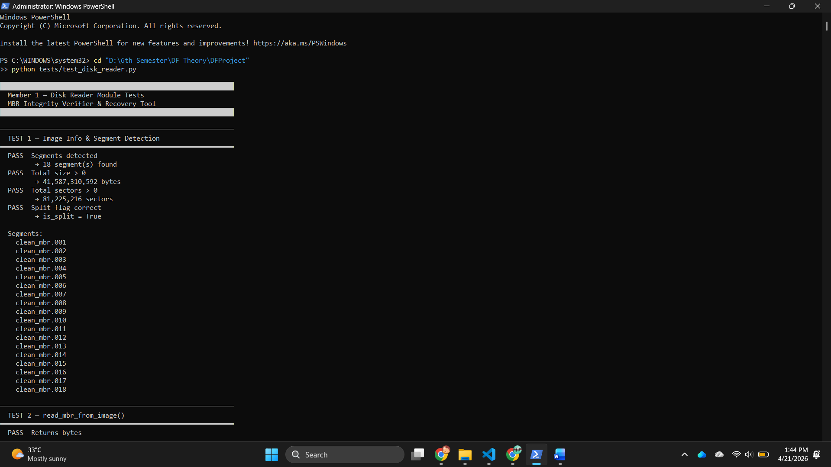

Case 2: Two Separate VHDs created (mbr_test.vhd & gpt_test.vhd)
This case uses two controlled virtual hard disks created specifically for testing the MBR and GPT parsing and integrity modules.
A 1 GB fixed-size VHD (mbr_test.vhd) was initialized using the MBR partition scheme and divided into two volumes: a 100 MB FAT32 partition (type 0x0C) and the remaining space as NTFS (type 0x07). This disk is used to test boot signature validation (55AA), boot code hashing, partition table parsing, tampering detection, and recovery functionality.
A second 1 GB fixed-size VHD (gpt_test.vhd) was initialized using the GPT partition scheme and contains an EFI FAT32 partition and a main NTFS partition. This disk is used to test GPT header parsing, verification of the "EFI PART" signature, extraction of CRC values, and comparison between primary and backup GPT headers. These structured test environments ensure controlled and repeatable forensic analysis.
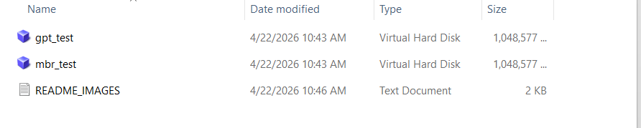
Results of disk reader (Member 1 part – for testing):
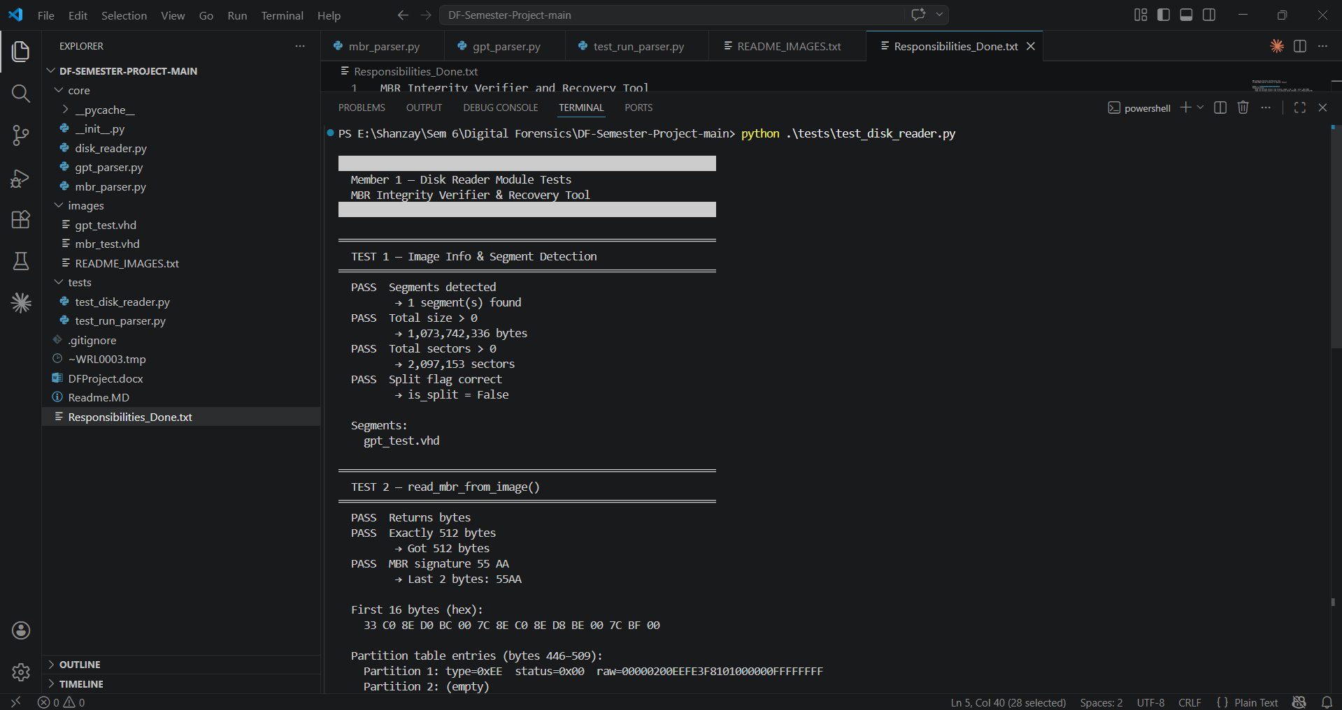
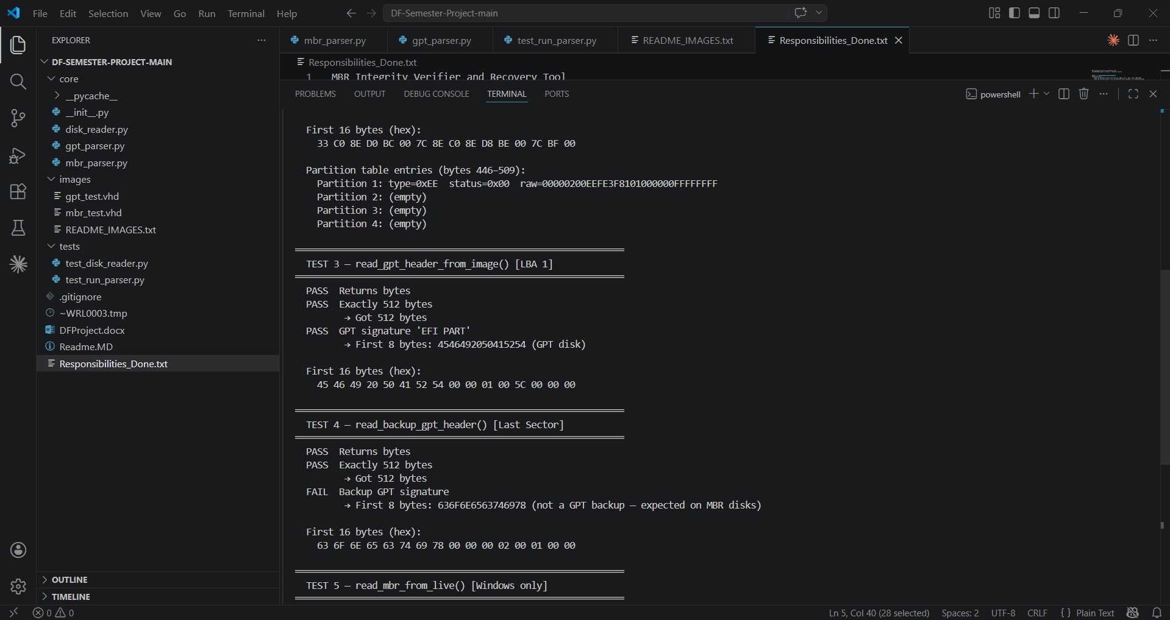
Results of Parser:
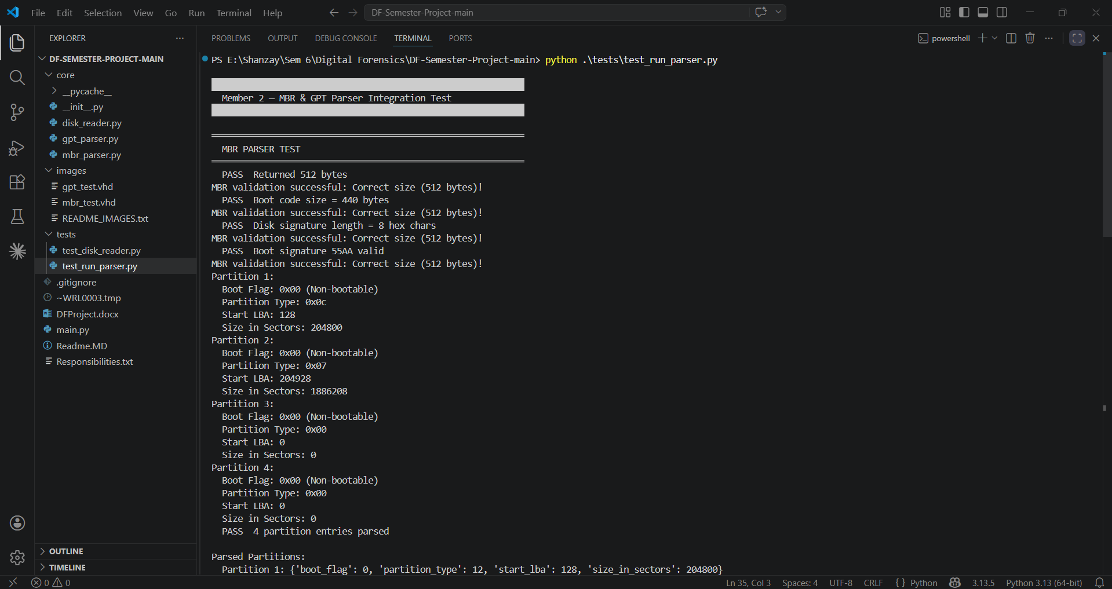
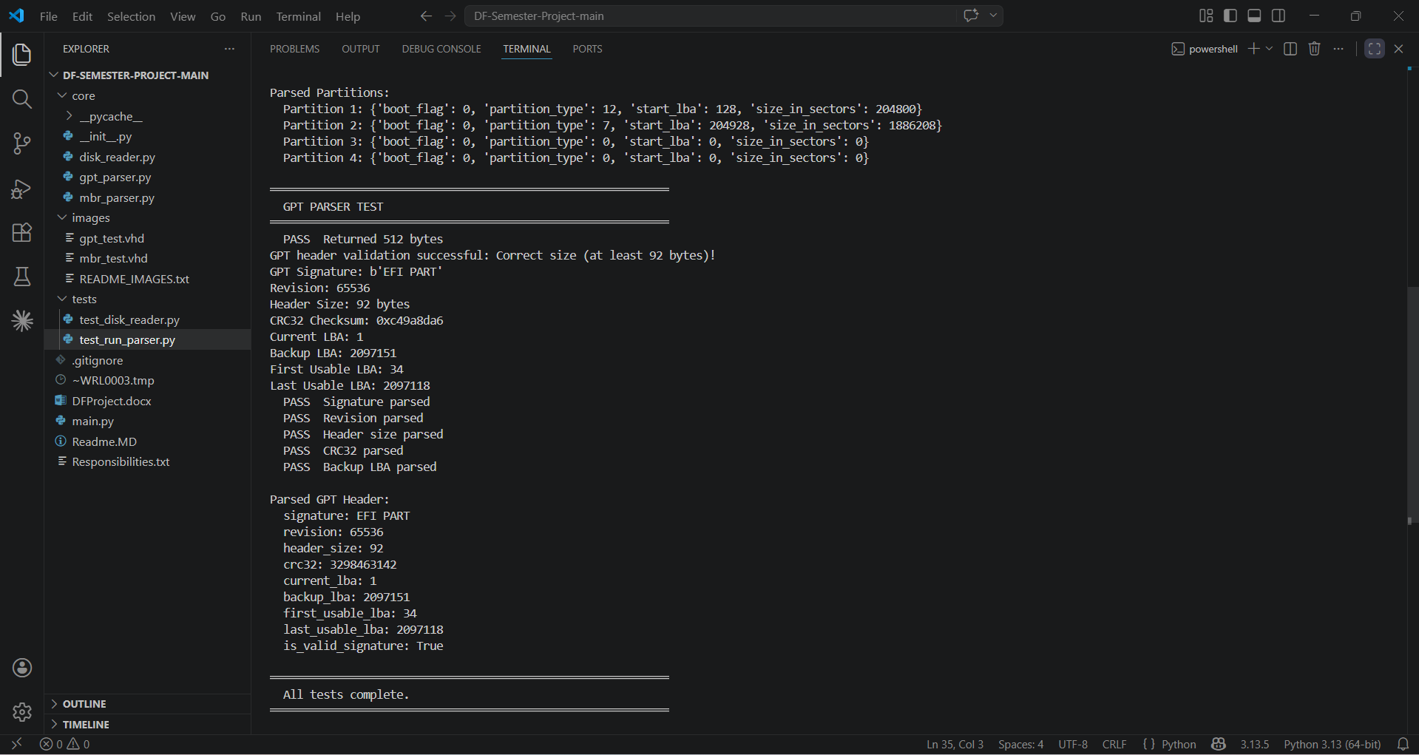
GPT & MBR Partition Table Analysis (Optional Feature)
In addition to header parsing, the tool can also analyze the GPT & MBR partition entry table. This feature extracts detailed partition information including start and end LBA, partition names, and type GUIDs. The function processes raw GPT entry data and converts it into structured forensic output, enabling investigators to view actual disk partition layouts and detect hidden or suspicious partitions and respectively for MBR Partition Table.
MBR Partition Table Parsing Image: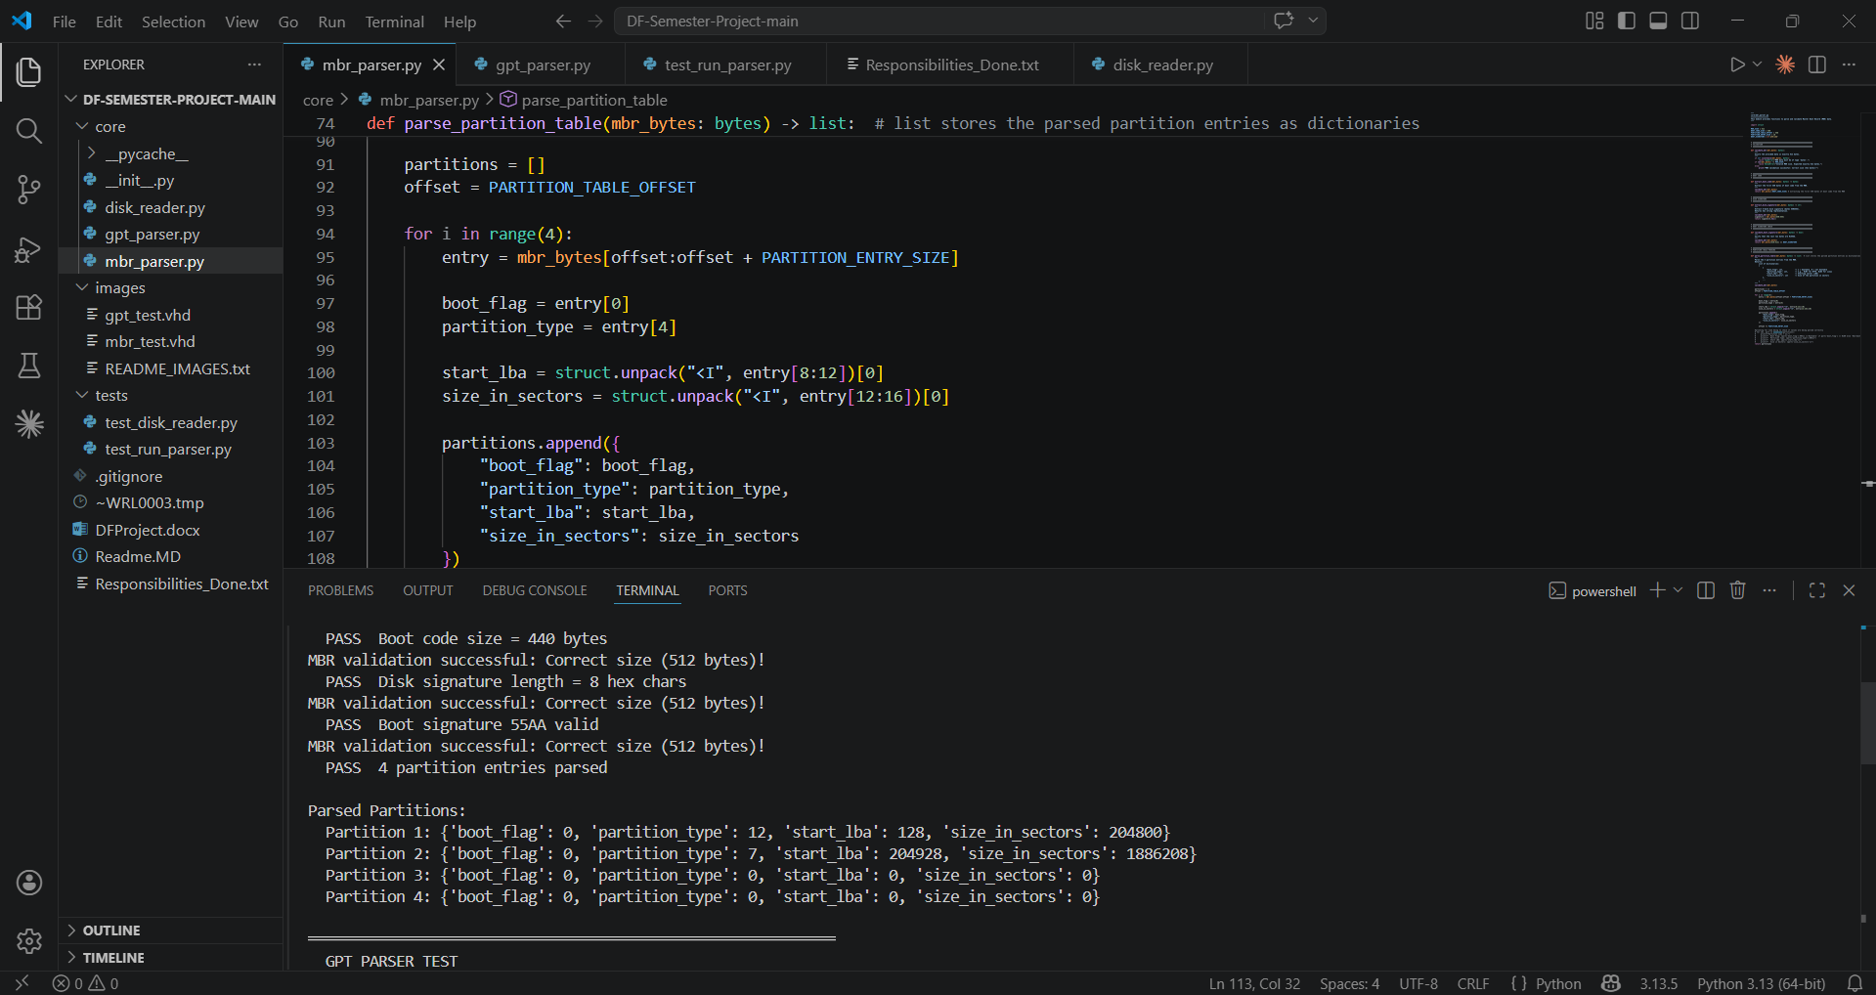
GPT Partition Table Parsing: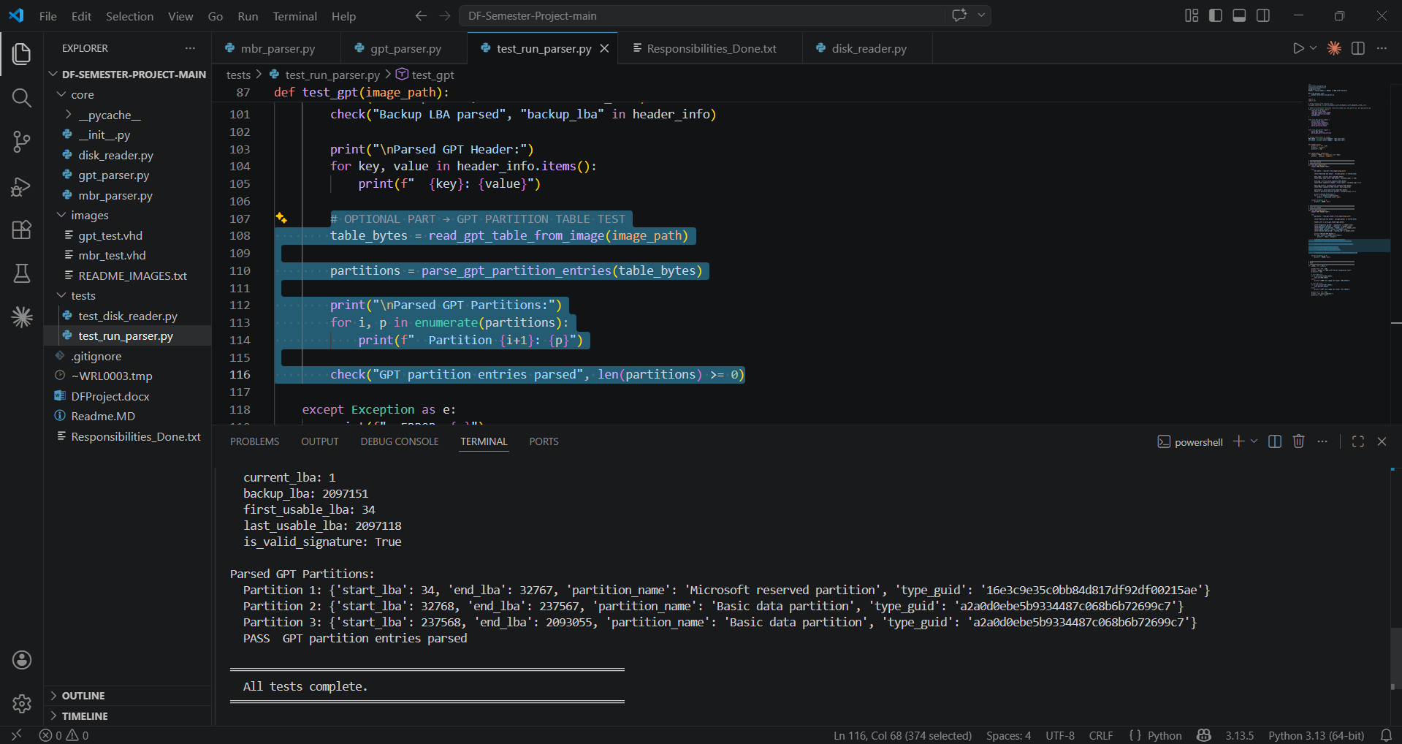

Interpretation of Results (Forensic Relevance)
MBR Signature (55 AA): The last two bytes of a valid MBR must always be 0x55 0xAA. This is the boot signature. If these bytes are missing or altered, the disk will not boot and the MBR may have been corrupted, either by malware, accidental overwrite, or deliberate anti-forensic tampering. In this case the signature was confirmed valid.
Partition Type Codes: Each partition table entry contains a 1-byte type code identifying the filesystem:
Type Code | Meaning | Found in this case
0x0C | FAT32 (LBA) | Partition 1 — 50 MB USB partition
0x07 | NTFS / exFAT | Partition 2 — remaining USB space
0x00 | Empty entry | Partitions 3 & 4
These codes are forensically significant because a mismatch between the declared type and the actual filesystem content can indicate partition hiding or deliberate manipulation.
GPT Result (zeros at LBA 1): The image returned all zeros at LBA 1, confirming this is a pure MBR-partitioned disk with no GPT structure. This is expected and consistent with a standard USB drive. On a GPT disk, LBA 1 would contain the EFI PART signature, its absence here is not an error.
Split Image Reassembly: The 18 segments were automatically detected and reassembled virtually. No data was written to disk during this process, the tool reads each segment in sequence purely in memory, preserving the integrity of the original evidence files. This is consistent with forensic best practices for read-only evidence handling.
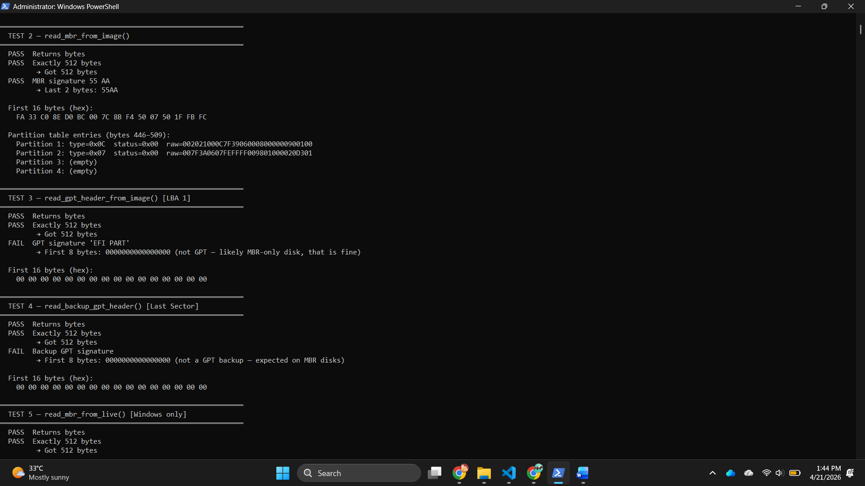
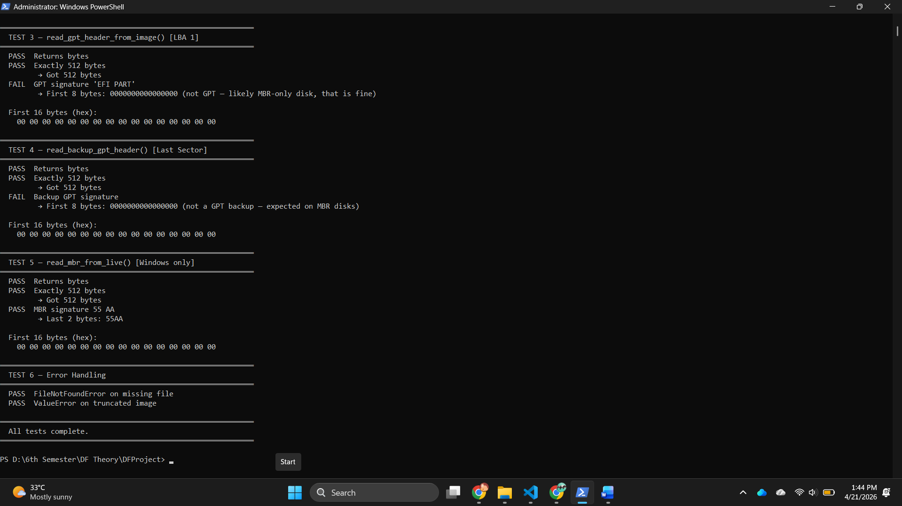
Analysis After Parsing:
MBR Parsing Results: The parsed MBR confirms a valid and consistent disk structure. The boot sector (512 bytes) was successfully extracted along with a correct boot signature (55AA), indicating the disk is in a bootable MBR-compliant format. The partition table analysis revealed two active partitions: a FAT32 partition (type 0x0C) starting at LBA 128 with 204800 sectors, and an NTFS partition (type 0x07) starting at LBA 204928 with 1886208 sectors. This layout reflects a typical dual-filesystem storage configuration. The absence of bootable flags (0x80) indicates that no active boot partition is set, which is consistent with a non-system data disk. The remaining two partition entries are empty (0x00), confirming no hidden or additional partitions exist within the MBR structure. Overall, the MBR structure is clean, consistent, and shows no signs of tampering or misalignment in partition metadata.
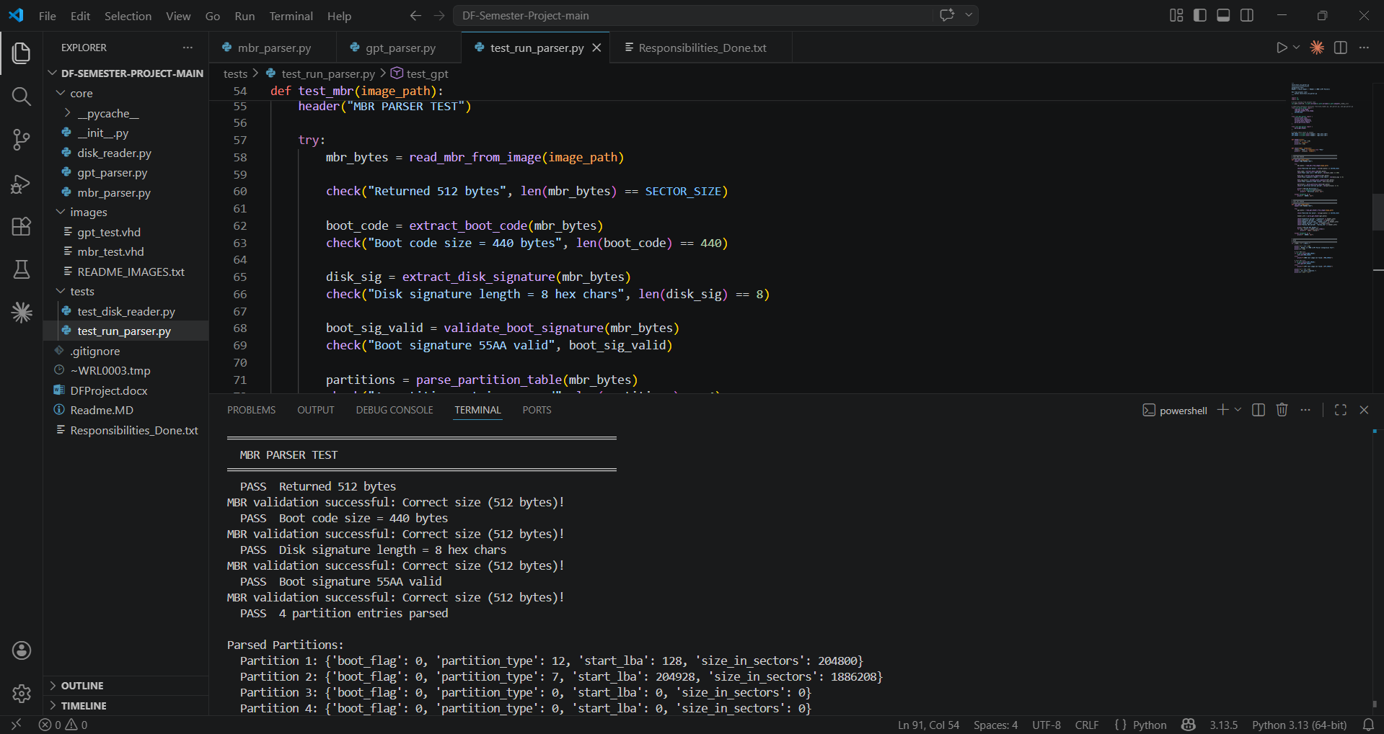
GPT Parsing Results: The GPT header was successfully parsed from LBA 1 and validated against expected structural fields. The signature "EFI PART" confirms a valid GPT-compliant disk layout. The revision value (65536) and header size (92 bytes) match standard GPT specifications, indicating correct header formatting. The CRC32 checksum (0xc49a8da6) was extracted for integrity verification purposes, though full validation is handled in the integrity module. The current LBA is correctly set to 1, while the backup GPT header is located at LBA 2097151, confirming proper GPT redundancy structure. The first usable LBA (34) and last usable LBA (2097118) define a valid usable disk range, ensuring reserved sectors for system metadata are intact. Since no comparison with backup header was performed at this stage, this module strictly confirms structural correctness rather than integrity validation. Overall, the GPT layout is intact and conforms to standard disk partitioning specifications.
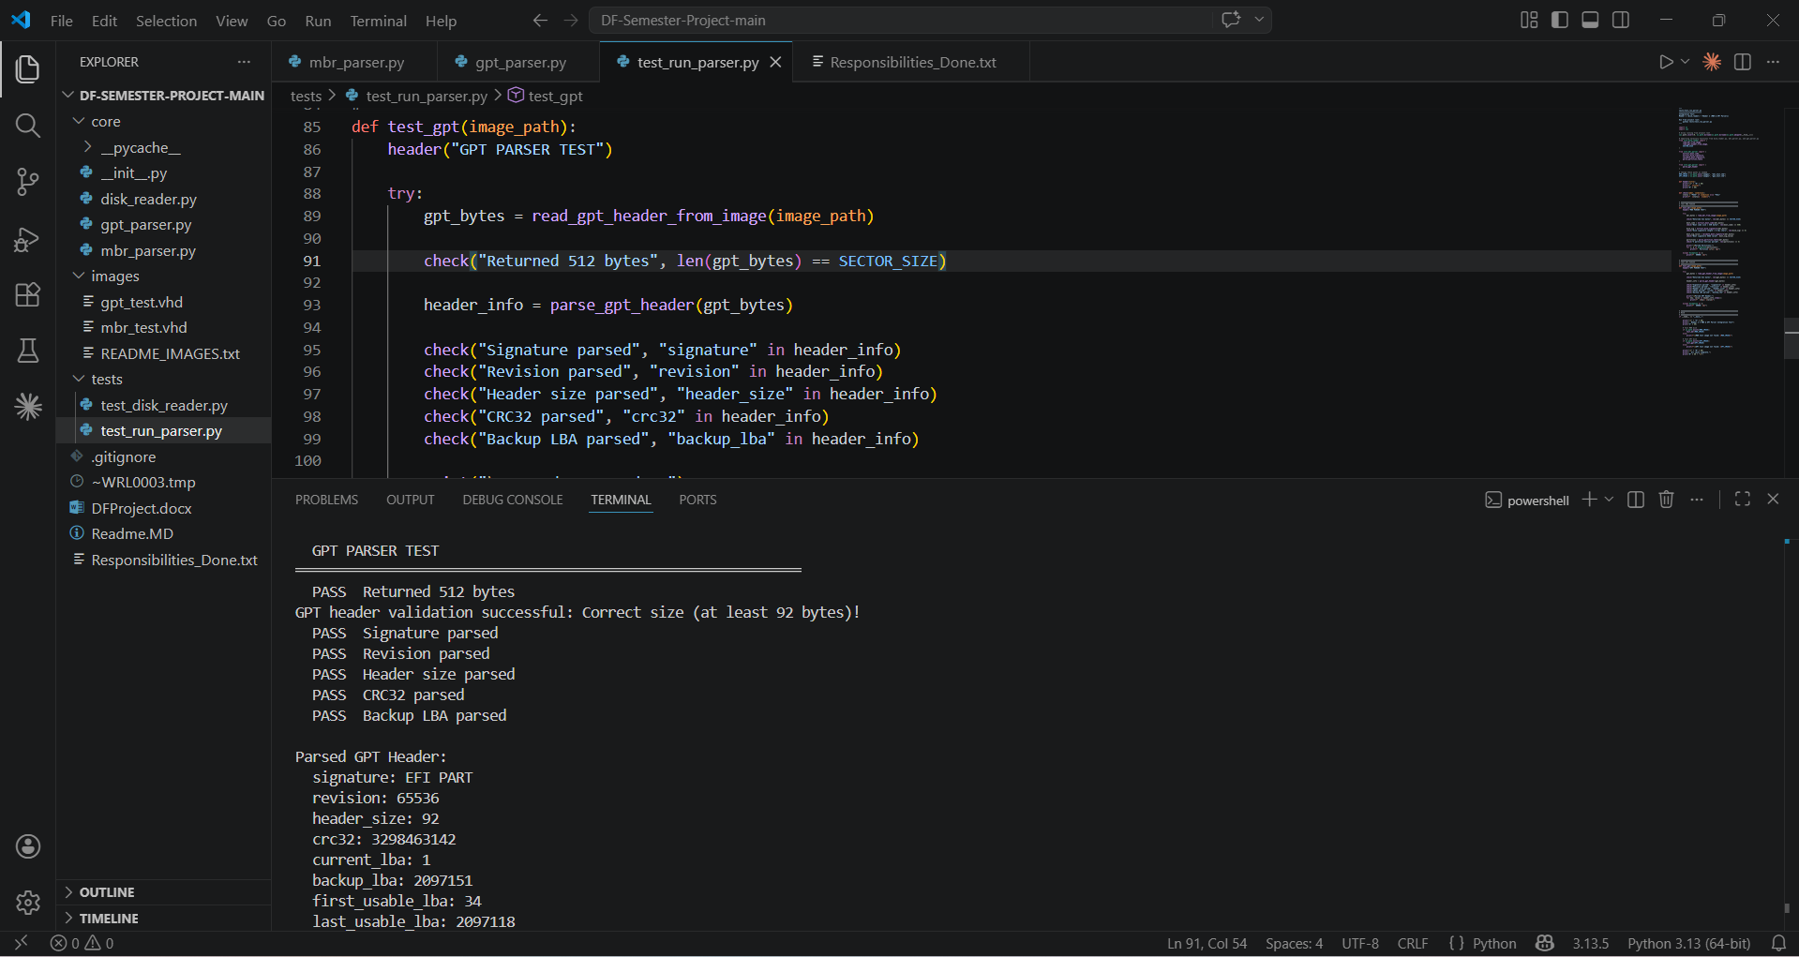

Work Division
The project MBR Integrity Verifier and Recovery Tool was developed collaboratively by a team of four members. Each member contributed to a distinct technical module of the system to ensure modularity, maintainability, and clear separation of forensic responsibilities.

Member 1 — Disk & Image Handling Module
Modules Developed:
- core/disk_reader.py
Technical Contributions:
- Implemented low-level disk access functions for forensic image analysis and live system access.
- Developed support for reading raw 512-byte sectors from:
  - Forensic disk images (.dd, .img, and split .001–.00N formats)
  - Live physical disks (Windows PhysicalDrive access)
- Implemented GPT-aware sector reading including:
  - Primary GPT header extraction (LBA 1)
  - Backup GPT header extraction (last sector of disk/image)
- Designed split-image reassembly logic for multi-segment forensic images.
Key Constraint Followed:
- All functions strictly return raw bytes with no processing, hashing, or interpretation.

Member 2 — MBR & GPT Parsing Module
Modules Developed:
- core/mbr_parser.py
- core/gpt_parser.py
Technical Contributions:
- Developed MBR parsing engine to extract and structure:
  - Boot code (440 bytes)
  - Disk signature (4 bytes)
  - Partition table entries (4 × 16 bytes)
  - Boot signature validation (0x55AA)
- Implemented GPT header parser to extract:
  - Signature (“EFI PART”)
  - Revision and header size
  - CRC32 checksum field
  - Current, backup, first usable, and last usable LBAs
- For Optional feature, parsed partition table entries for both GPT & MBR.
- Converted raw byte-level disk data into structured forensic dictionaries for further analysis.
Key Constraint Followed:
- No hashing, integrity validation, or recovery logic implemented in this module.

Member 3 — Integrity Verification & Recovery Module
Modules Developed:
- core/integrity_checker.py
- core/recovery.py
Technical Contributions:
- Implemented cryptographic integrity verification using SHA-256 hashing of MBR boot code.
- Developed boot code verification system using a hardcoded reference hash.
- Designed GPT integrity comparison logic between primary and backup headers, including:
  - Signature validation
  - CRC consistency checking
- Implemented forensic recovery mechanism that:
  - Restores corrupted boot code (first 440 bytes only)
  - Preserves partition table structure
  - Recomputes hash after recovery to confirm integrity restoration
- Demonstrated tamper detection by modifying boot sector data and validating detection accuracy.

Member 4 — GUI Interface & Reporting Module
Modules Developed:
- gui/main_window.py
- reports/report_generator.py
- main.py
Technical Contributions:
- Developed graphical user interface for interacting with forensic modules.
- Integrated backend modules into a unified workflow:
  - Disk reader → Parser → Integrity checker → Recovery system
- Implemented interactive controls for:
  - Loading forensic images
  - Selecting live disks
  - Running MBR/GPT verification
  - Triggering recovery operations
- Developed automated PDF report generation using reportlab, including:
  - MBR hash results
  - GPT analysis results
  - Partition structure summary
  - Integrity verification status

References
(NIST), N. I. (2024, February 26). Retrieved from The NIST Cybersecurity Framework (CSF) 2.0: https://doi.org/10.6028/NIST.CSWP.29

